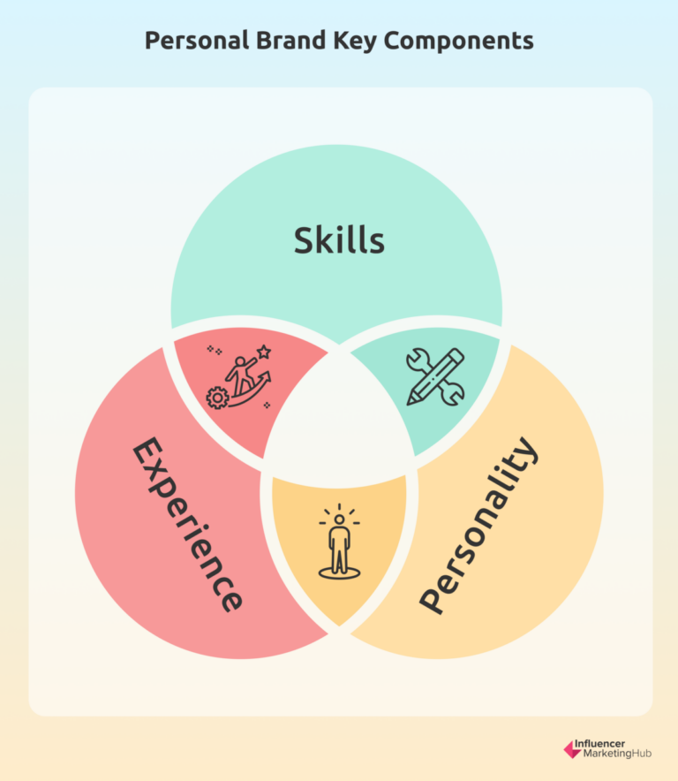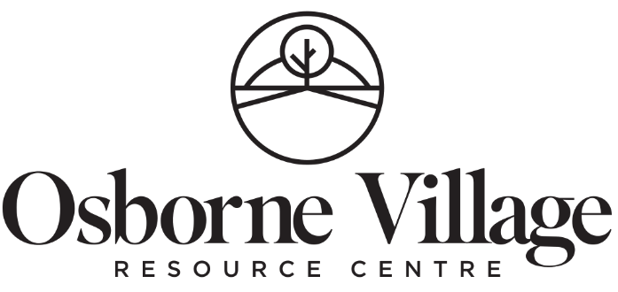

**Personal Brand**

*Image ©* [*Influencer Marketing Hub*](https://influencermarketinghub.com/what-is-personal-branding/)*, 2024*

Table of Contents

Why do we need a personal brand / elevator pitch? 3

“So, what do you do for a living…? 3

But I don’t need a “pitch”, I’m not selling anything! 3

Why do employers not post things publicly? 4

Well, that sucks! What do I do, then? 4

Networking – as we see it – is not what you think it is… 5

The power of networking is in close circles and “two degrees of separation”…. 5

Adaptability is key to success in personal branding 8

What are the parts of a personal brand / elevator pitch? 8

Section One: Job Title / Industry / Years of Experience / Education 9

But [internet source] says I have to talk about my education in my brand….? 11

Section Two: What do you offer a potential employer? 13

Skills: Things we know HOW to do, that we are GOOD AT, that we ENJOY 14

Attributes: Ways that we ARE, or Personality TRAITS 18

Values: WHY we do what we do? Personal STRENGTHS? 19

(Optional) Evidence / Metrics 20

Let’s Check In: Remember that context matters! 21

Section Three: What do you want? What happens next? 22

Can you write it **for** me?? 22

The importance of Gratitude to set the tone 23

Wording each section 23

Personal Brand Scripts (samples) 24

Putting it all together 26

Write It Out – Draft your Personal Brand here! 27

Practice makes progression and then permanence! 28

Where else can we use our branding statement? 29

In Summary 29

Map out your network here 32

# Why do we need a personal brand / elevator pitch?

## “So, what do you do for a living…?

This single, seemingly harmless question has caused more job seekers more anxiety than all the recessions in the world. Because most of us don’t know how to answer it clearly and concisely.

The idea of introducing yourself through your job title seem to be a uniquely North American concept and it can be frustrating to people for a lot of reasons:

1. You may not have a job right now but don’t want to say you’re unemployed
2. You’re brand new to the job market (just graduated) or coming back after a long absence and it’s “complicated”
3. You may be in career transition (changing jobs) and your new job goals may not match up with your current role or past work history
4. You’re a new Canadian and you don’t even understand why someone would ASK that
5. You may feel like it’s very intrusive, like they’re going to judge you on how you respond.

All of those things can be true. In fact sometimes more than one is true at once!

However you may feel about the question (and lots of clients don’t feel great about it), it’s important to have something short, well rounded, and pleasant to say in response.

Enter the elevator pitch, or as we like to call it, the personal brand (or sometimes self-introduction) – your 20-40 second gateway to career networking in social settings.

## But I don’t need a “pitch”, I’m not selling anything!

Yes you are - and the thing you are selling is YOU.

People misunderstand how job search ACTUALLY works, and there’s many reasons for that. The most important reason, and the one that leads people astray is the increasing reliance on doing the job search online. We’ve been led to believe all we have to do is pump out as many online applications as possible and a job will magically happen.

However…

The reality is, that’s not efficient or effective. For most people that’s the difference between finding the job you can GET vs. getting the job that you WANT. OVRC does not pride itself on finding people “crummy jobs you hate”; we are going for “meaningful employment”.

What meaningful actually looks like is as individual as the 1000-1500 clients we serve every year. We’re not here to tell you what that means to you. (The career counsellors can help with some nudging in finding your right direction though...)

[](https://www.google.ca/url?sa=i&rct=j&q=&esrc=s&source=images&cd=&ved=0CAcQjRxqFQoTCP_r89rDkscCFUpdHgodA7oKHA&url=https://www.jobsrmine.com/blog/using-public-sources-to-tap-the-hidden-job-market&ei=JFDCVf_JDsq6eYP0quAB&bvm=bv.99261572,bs.2,d.eXY&psig=AFQjCNEX1w-FR7Aoy-Efpo5OYeeJL2Mlmw&ust=1438883859923957)The reality is, as much as we’ve implemented all these silly barriers – ATS systems, keyword matching, online applications and so on – we’ve learned over decades of helping people just like you that the best way to find that mythical “good job” is still word of mouth.

That means networking, since most of those jobs will never see the light of day. This frustrating phenomenon is sometimes called the “hidden job market” and it can represent anywhere from 50-85% of jobs that actually exist.

# Why do employers not post things publicly?

Oh, there’s tons of reasons, but we’ll address some of the most common (and tricky) ones here:

1. Posting job ads can be expensive – Indeed and Kijiji may be free once or twice, but then they want money – and posting in the paper can be ridiculously costly
   * Also, if you’re a small company and not tech savvy this can be a hassle
   * Furthermore, posting to a public Internet job bank will net an OVERWHELMING response – not dozens, or even hundreds, but maybe THOUSANDS of resumes
2. Sometimes the company isn’t even aware that they need a new hire; the whole department may have been treading water and bailing the boat for months or years
3. Nobody has time – they have a business to run and the hiring process is exhausting and takes weeks, never mind wading through the deluge of applicants
4. Maybe the person is a one-person-band with several roles worth of responsibilities that they grew into over time and they can’t figure out how to break them up again
5. If the person is on medical leave, then there may be legal reasons why they can’t replace them, or ethical ones why they don’t want to, so they won’t post anything

This is a handful. This list could go on for another ten or twelve pages. And if you come from a country where being open about postings and salaries is federally mandated, it can be incredibly confusing and frustrating to have this “shady thing” going on in the background!

## Well, that sucks! What do I do, then?

Yes, we freely admit, it kind of does. The way to break free of this annoying situation is personal networking. And that all starts with a brand – a short, clear statement about what you are trying to do professionally and some clues as to why you are good at it. Maybe two to three sentences. *Not a Shakespearean monologue that goes on for five minutes.*

The thing is, if you cannot explain to someone else, in fairly simple language, what your career goals are, **how can they possibly help you meet them**?

# Networking – as we see it – is not what you think it is…

[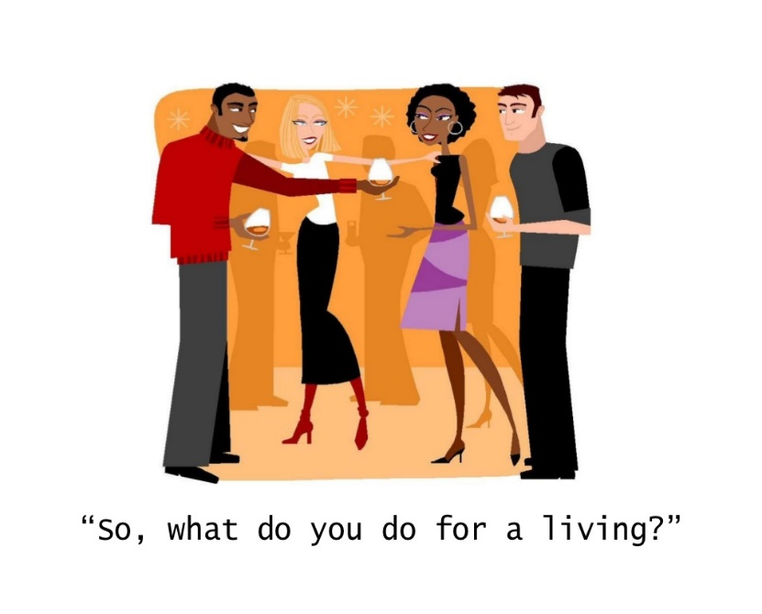](http://www.google.ca/url?sa=i&rct=j&q=&esrc=s&source=images&cd=&cad=rja&uact=8&ved=0ahUKEwiogMD1mILLAhUK4SYKHeP3Cj4QjRwIBw&url=http://ofslides.com/mandhshow-138635/presentation-256608&psig=AFQjCNHY4Ci5VGIB4J342HW0wU81B-8TFg&ust=1455915039449077)

Most of the clients we deal with figure networking is pretty, well, squick. They don’t feel comfortable with it, they maybe figure it’s a bit sleazy, and they’re not comfortable with the idea. (Salespeople and marketers, we’ll come back around to you later – networking is your lifeblood and you’re probably perfectly okay with it.)

Networking is just talking to people about stuff. Honest. Most of us do it every day when we suggest a favorite restaurant or give someone the number of the people who DJed our social or made our cool earrings. We don’t generally ask complete strangers for help with a complex problem, we ask people we trust. Since hiring is one of the most complex problems a company can ever face, of course they’re going to ask around for help before they post a job ad and get buried in hundreds of responses!

Over the years, we developed this idea that networking was a lot of people in dark rooms, drinking, smoking, and sharing insider gossip. Or worse, some sort of horrible wine and cheese speed dating thing where you shoved your business card at people and assaulted them with a three minute lecture about why you really needed a job. Of course nobody wants to do THAT.

We see networking as more organic than that. At it’s core, it’s sharing a little about you and maybe getting some advice to help you along, or asking someone if they know who can help.

Most of the really powerful networking happens at bridal showers, barbeques, broomball, and bus stops. And it starts with the people you love, who love you, and who want to see you be successful. It doesn’t start with total strangers. (We get to strangers later.)

## The power of networking is in close circles and “two degrees of separation”….

On the back of this booklet, you will see a starburst. This is how we are going to start building YOUR network in a minute. But first, let’s explain why this is going to help you.

Most of your close circles have no idea what you actually “do for a living”. They may know your job title (for all the good THAT will do them, most of the time), but they don’t understand your job or why you’re good at it, much less why you love it.

Therefore, we start networking, not with strangers, but with our friends, family, and communities. Sometimes people point out those people don’t know anything to help you – which is a valid concern. We’re not in this for only those first level people, we’re in it for their friends, and their friends’ friends.

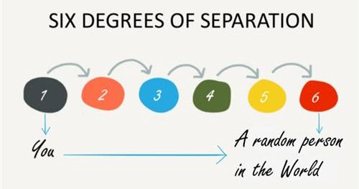

Back in the mid nineties, some of you may remember a movie called Six Degrees of Separation. The movie is a con game film, but it introduced this interesting idea that we are all only six degrees of separation (or relationships) from any other person in the world.

Your friend or your cousin, or your partner’s bowling team may not be able to help you directly, however – and this is really important – **you don’t know who THEY know**. Or who their friends may know. And this is where the magic happens; in those second or third degrees of separation, potential connections you can’t even imagine right now

Winnipeg is an 800,000+ person “small town” and those connections can be strange, wonderful, and way closer than you think!



Let’s use a silly example: You don’t know anyone at NASA. But I know someone socially who works in the science research industry, and they JUST went to NASA for a satellite launch and hung out with people at NASA and JPL for most of a week. So ***they*** DO.

Locally, we may not know anyone who works at, say, Price Industries or True North Centre or Manitoba Hydro. But we can talk to our close circles, express some interest, and maybe they can help us find someone who DOES.

With that in mind, let’s start filling in the starburst on the back. First names are fine, we’re just capturing some high level stuff here. We’ll approach each category one at a time:

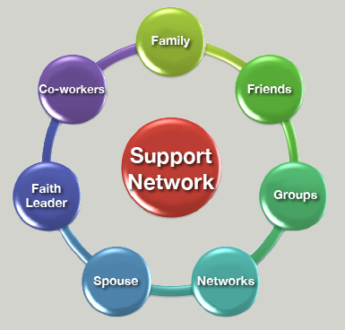

**Family:** This is immediate (and extended) family – siblings, parents, cousins – who are supportive of your job search. (Not the ones who think you should give up.)

**Friends:** Your buds, your pals, your squad. Only choose people that you think might have a sense of what you do. Don’t forget to capture those people who just “know EVERYONE”.

**(Social) Groups:** This is for more socially oriented groups that don’t fit anywhere else. Your pickleball league, your book club, the people you play bridge or D&D with.

**(Professional) Networks:** These are your professional groups and associations. Industry sector councils, unions, lobbying groups for your industry, former classmates and teachers.

* Remember, OVRC counts here, so add the people who have helped you!

**Spouse:** Don’t forget the people your spousal unit knows! Not all of their friends will be mutual to both of you and you might be surprised who can help there.

**Faith Leader / Faith Community:** Not all of us belong to a structured faith community, but these people can be a goldmine of connections (and you probably see them once a week).

**(Former) Coworkers:** People you used to work with that you have a good relationship with are a great resource! They know how you are to work with and can talk you up.

Fill in as many circles as you can. It may not be many to start, and you can keep working on this when you get home and have some time think on it a little more. Don’t be afraid to ask people you have written down for ideas!

# Adaptability is key to success in personal branding

Before we can start building on all those connections, we need to be able to present ourselves clearly and briefly while explaining what we are trying to do with our career – enter the personal brand, branding statement, or elevator pitch.

The brand has to change depending where we are; you certainly won’t talk about your career goals with Great Aunt Mathilda at your nephew’s piano recital with quite the same tone and language than you might talk about them at a job fair.

Depending on where you are in your career, your pitch will be different. We’re tailoring these directions to early to mid career bracket where you might need more help articulating what your unique selling proposition is, either because you’ve never thought about it or because it’s changed radically.

NOTE: Higher level job seekers might use a structure more like “tell me about yourself”, a sentence or two about your past, a sentence or two about your present, and a sentence about your future or your desired outcomes. You may be able to gather some ideas about what to put into those sentences from this exercise.

# What are the parts of a personal brand / elevator pitch?

A personal brand is, at it’s core, three things:

* Who you are and what you want to do (job title, industry, experience level)
* What you have to offer (skills, attributes, values, evidence)
* Where do we go from here (how they can help / what you need)

Socially speaking when we’re talking about a verbal introduction, your personal brand shouldn’t exceed three or four sentences, maybe thirty to sixty seconds in duration at the most.

When we’re writing an email or a LinkedIn message, obviously we can provide a little more detail, but we still want to keep it under, say 200 words.

It’s an introduction, not your whole life story with a PowerPoint slide deck. ☺

NOTE: At informal social gatherings (weddings, barbeques, birthday parties, waiting in line at the movies), we may not talk about outcomes, we may just ask something like “how do you know the hosts?” or talk about the event itself. You want to invite a dialogue, not frighten people with how desperate you are to find a job.

## Section One: Job Title / Industry / Years of Experience / Education

The first thing we need to think about saying, other than our name, which was probably covered before we got to the Awful Question, is what we’re trying to do professionally.

If you are working with a career counselor and you are still a bit lost here, that’s okay. This doesn’t have to be very precise. “I want to work with animals” is as good of a start as anything.

NOTE: Job titles are tricky and half the time they are a terrible way to describe what you do. If it’s something obvious like accountant, lawyer, teacher, or nurse, then great, use that. If your job title is something like “Interdepartmental Coordination Liaison”, that won’t say much. I don’t even tell people I’m an “employment facilitator”, I just say I write resumes and cover letters for a living. They can get their head around that.

Before we begin, and I cannot stress this enough:

**“Anything” is not a job title or career goal.**

At best, it is a desperate plea for attention. At worst, it is a complete turn-off for the listener, who is now feeling really awkward. And it isn’t true at all; when we drill this down it turns out that oddly, there are lots and lots of things they don’t want to do.

What you may see as being open to options doesn’t come off that way at all, especially when your friends and family get fed up with feeding you opportunities and having you turn them all down. “Anything” is not a placeholder for customer service work either.

1. If you have a clear, easy to understand job title you’re going for, let’s write that down:

JOB TITLE: ______________________________________________________

If your job title is unclear or you’re changing paths, sometimes it’s easier to think in terms of a job field or industry. For example, maybe you know you want to work in education, or in social services, or in information technology, or in a warehouse.

1. If you’re not 100% sure, but you know a general industry or field, write that down

JOB FIELD / INDUSTRY: ________________________________________________

Maybe we’re not even that far along the employment path. “I want to work with animals.” “I think I want to work in a kitchen.” “I like helping seniors.” That’s okay, we can use that as a starting point as well.

1. If you have a vague direction aka, “I want to, I like, maybe”, let’s capture that

CAREER INTEREST: _____________________________________________________

NOTE: Sometimes people think interests have to become careers. Decades of helping clients shows that just because you like cooking or you like dogs doesn’t mean you should become a cook or a veterinarian. Hustle Culture (thanks for nothing, 2000s) has created this notion that all passions must be sellable, and worse, that if we’re going to do it, we have to be a pro. Tread carefully if you’re looking to turn a passion into a career, and do your homework. Have the career conversations to make sure you know what it really is and not what you think it will be.

You’re not going to rattle off all three of these things. You’re going to pick one and build around that. This is part of a longer sentence, probably.

1. How many years of experience do you have doing The Thing? (Volunteering Counts!)

YEARS OF EXPERIENCE: ____________________________________________



This can get a bit complicated but a good general guideline here is:

1. No experience or less than a year, say you’re “looking to build experience”
2. One to twelve years of experience: just use the number
3. Over 12 (maybe over 15), you may want to just say “extensive experience”

Why all the fuss over how long you’ve done your job or volunteer gig?

Well, age discrimination is illegal, and, let’s face it, human beings will count on their toes given half a chance and make assumptions. That never ends well for you as the job seeker. If you say you have thirty years of experience, that makes you at least fifty and closer to retirement than not, which means they may be hesitant to invest in you.

It’s not right, it’s not fair, it’s not legal, and it HAPPENS. So let’s not make that any easier for them than we have to, shall we? You think it shows loyalty and expertise, and we can tell you that’s not what really happens on the other side of the desk.

Let’s start putting that together into a sentence; here are your “parts””

I’m looking for work / looking to build experience

as a / in / doing / specializing in

with XY years’ / extensive experience.



Here are some real world examples of the first line:

* I’m looking for work as a nurse specializing in geriatric care with seven years of experience in Winnipeg hospitals.
* I’m looking to build experience as a web designer specializing in graphic design.
* I’m looking for work as a custodian with extensive experience working in residential buildings and property management.
* I’m looking to build experience in the construction industry because I like working with my hands to make cool things.
* I’m looking for work as an accounting clerk with twelve years of international experience in the banking and financial industry.
* I’m looking to build experience in a job where I can work with animals and help them find permanent and loving homes.

You can use other words, some people like “hoping” instead of looking when you’re building experience in a new field. Sometimes people like “looking for my next position / role” instead of looking for work. The point here is to get SOMETHING written down. You can’t edit what you don’t have. And keep it SHORT. For now, add your first line “parts” to Page 26 of the manual.

### But [internet source] says I have to talk about my education in my brand….?

Sometimes. The Internet Isn’t Always Right. [tm] Shocking, I know!!

If, and ONLY if, your education is relevant to the kind of work you’re looking to do, you can add it as a “second” sentence. Now, the definition of “relevant” can be pretty flexible, and you still have to make it make sense.

If you are trying to get an accounting job with a bank or credit union, a master’s degree in ceramics is probably not helpful, no matter how much we stretch the definition.

Sometimes we’ll have a lot of education, or education in different things that aren’t really connected to each other. You can have a second level carpentry certificate AND a health care aide certificate – you only talk about the RELEVANT thing.

Education can include self-paced and online learning as well. Not all learning happens in a classroom. Volunteering may be useful as “learning” too.

Examples of how to “add” to the sentences above:

* I have my Registered Nursing Diploma from the University of Manitoba.
* During the pandemic, I’ve been studying front end development through CodeAcademy and LinkedIn Learning.
* I’m working on my Power Engineer Class 5 and I have two levels of Carpentry from Red River College.
* I volunteered for Habitat for Humanity before the pandemic and want to make building things into my career.
* Before I came to Canada, I got a Bachelor of Economics with a minor in Accounting from Ashoka University in New Delhi, India.
* Recently I’ve been volunteering for Annie’s Attic and really enjoy working with cats.

As you can see, the approaches are as unique as you are. And remember, if you’re really struggling to come up with something because you don’t have relevant education (hey, sometimes we dropped out of high school and learned everything on the job, and that’s cool too), then don’t lose any sleep and skip this bit for now.



## Section Two: What do you offer a potential employer?

Now we’re going to start building the individual pieces of our brand. Sometimes when we don’t have a clear job goal yet or we don’t have education that applies to our career direction, we’re going to have to start here.

For each of the three sections, you’re going to select as many options as apply – HOWEVER – in the end you will chose a maximum of three items. You will NOT be using all three items from each category in your brand, they become part of a set of mental “flash cards” you can choose from when you structure your reply.

**Skills** are *what you do* in your role. We see 1000 - 1500 people a year, so obviously we can’t include every possible specialty. However, we’ve put together some commonly mentioned skills, arranged by category or field. There are some blank lines at the end to write in specialty skills you may have that aren’t covered elsewhere. Some skills will have a blank space to write in your specific certification (e.g. a non-typical trade.).

**Attributes** are personality traits, or *ways that you are*, regardless of the role or environment you are in. Sometimes we call these “I am” statements. Attributes are often confused with skills (for example, I am organized vs. I organize things). It is important to be honest here and not choose options because you think you have to or you should. Being terrible at multitasking is human nature and it might mean you are better at focused tasks.

**Values** are why you are. Your strengths, the things that really matter to you at your core, are what drive you to be successful and they’re different for everyone. Some people value being active and some people value connecting and some people value gold stars. And that’s okay.

### C:\Users\betpun\AppData\Local\Microsoft\Windows\INetCache\Content.MSO\F82AEA27.tmpSkills: Things we know HOW to do, that we are GOOD AT, that we ENJOY

This section spans several pages. Start by choosing EVERYTHING that fits the criteria and then moving your TOP THREE over to page 26

|  |  |
| --- | --- |
| **Administrative / Clerical**   * ***Reception:*** Phones / Email / Switchboard * Scheduling Appointments * Managing Calendar(s) * Document Creation / Editing * Data Entry * Incoming and Outgoing Mail * Office Supplies / Inventory * Petty Cash / Cashbox * Expense Reporting * Payroll / Timesheets * ***Microsoft Office:*** Word / Excel / Outlook / PowerPoint / Teams / Access / Project * ***Google Suite:*** Docs / Sheets / Calendar / Slides / Drive / Meet | **Accounting / Financial**   * Accounting (full cycle) * Accounts Payable / Receivable * Account / Credit Card Reconciliation * Budgeting * Forecasting * Expense Reporting * Risk Management * Payroll * QuickBooks * Sage 50 / 300 * SAP Financials * GAAP / IFRS (general accounting) * CSC / IFIC (securities / investments) * Compliance (regulatory) |
| **Computers / Information Technology**   * Network Administration / Technician * Security / Cybersecurity * Documentation / Technical Writing * Website Administration * Front End / Back End Development * Database Administration * Bench Work (assembly / installs) * Quality Assurance (Testing)   ***Software Development:***  Windows / Mac / iOS / Android  ***Programming Languages:***    ______________________________  ***Certifications:***  ______________________________ | **Cooking / Food and Beverage**   * Line / Prep / Short Order Cook * Chef / Sous Chef * Knife handling * Inventory Management * Bartending / Barback * Food and Beverage Server * Dishwashing * Cleaning / Sanitizing * Smart Choices Certified? Y / N |
| **Child Care / Educational Assistant / Teaching**   * Curriculum Development * Lesson Planning * Individual Education Plans * Behavioral Supports * Report Writing * Activity Leadership * Literacy / Numeracy Instruction * Facility Setup / Teardown |

#### Skills Page 2

|  |  |
| --- | --- |
| **Construction / Labour (incl. Cleaning)**   * Landscaping * Gardening * Cleaning * Housekeeping * Commercial Laundry (linens etc.) * Custodian / Maintenance * Power Engineer (level: ____)   ***Heavy Equipment Operation:*** Forklift / Skid Steer / Dozer / Tractor / Bobcat / Rock Truck / Tanker / Crane | **Creative / Marketing**   * Marketing / Promotions * Internet / Social Media * Graphic Design * Event Planning * Media Relations / Public Relations * Advertising * Journalism * Written Communications * Proofreading   ***Editing:*** Documents / Images / Video / Audio  ***Adobe Creative Cloud:*** InDesign / Photoshop / Illustrator / Acrobat Pro / Premiere Pro |
| **Customer Service / Sales**   * Customer Service * Point of Sale / Cashier * Inventory * Stocking Shelves * Merchandising (displays) * Negotiating * Public Speaking * Networking / Relationship Building * Sales B2B / B2C * Territory Management * Salesforce | **Engineering / Technologists**  **Specialization:** Aerospace / Chemical / Civil / Electrical / Geological / Industrial / Mechanical / Mining / Petroleum / Water (Wastewater)  **2D/3D Software:** AutoCAD / Inventor / Revit / SketchUP / SolidWorks / CATIA  **Analysis / Simulator Software:** ANSYS / MATLAB / LabVIEW / COMSOL /  **Mapping Software:** ArcGIS / Post GIS / BatchGEO / Mapitude  **PCL / Automation:** Siemens / Allen-Bradley / Schneider / Mitsubishi / ABB / Delta |
| **Health (Nursing / HCA etc.)**   * Medical Terminology * Intake / Triage / Assessment * Wound Care / Treatment * Medication Assessment / Dispensing * Intravenous Therapy (IV) * Care Planning / Discharge Planning * Incident Reporting * Physical Hygiene / Transfers * Meal Preparation / Feeding * Patient Education * Safety Planning / Hazard Awareness * Electronic Health Record / Charting | **Leadership / Management**   * Business Development * Program Coordination * Grant Proposals * Fundraising * Human Resources * Health and Safety * Open / Close (alarm / keyholder) * Management (Team of _____ people) * Recruiting / Hiring * Training / Orientation * Performance Coaching |

#### Skills Page 3

|  |  |
| --- | --- |
| **Manufacturing / QA/QC / Laboratory**   * Machine Operation * Equipment Calibration * Production * Quality Control * Report Writing * Data Collection * Research * Sample Analysis | **Project Management**   * Proposal / Tender Writing * Estimation * Budgeting * Scheduling / Planning * Technical Writing * Negotiation   **Software:** MS Project / Trello / JIRA / Asana / Confluence / Basecamp / Adobe Workfront  **Methodologies:** Prince2 / PMBOK / Agile / Scrum / Six Sigma / Lean / Kanban |
| **Social Services / Counseling**   * Intake / Assessment * Motivational Interviewing * Community Resources * Client Advocacy * Case Management * Networking / Outreach * Conflict Resolution * Workshop Development / Facilitation   ***Supports:*** Disability / Family / Indigenous / Newcomer / Youth  ***Counselling:*** Trauma / Family / Marriage / Addictions / Employment / ___________ | **Security / Corrections**   * Physical Patrols On Foot / Car * Video Surveillance * Visitor Log In / Log Out * Bag Checks (contraband) * X-Ray Scanner / Metal Detector * Incident Reporting / Security Logs * Safety Escort * Handling Difficult Situations * Non-Violent Crisis Intervention * Firearms Training |
| **Teaching / Educational Assistant / CCA**   * Curriculum Planning * Individual Educational Plans * Testing / Marking * Parent Meetings * Room Setup / Teardown * Activity Planning * Emotional Regulation * Physical Hygiene * Meal and/or Snack Prep * Incident Investigation * Progress Reporting | **Trades**  Carpentry / Electrical / Plumbing / HVAC  Automotive / Millwright / Power Eng. / Welding  *Other Trade / Apprenticeship:*  __________________________  Level 1 // Level 2 // Level 3 // Level 4  Red Seal Certified?  Pre-Employment Training: _______________ |

#### Skills Page 4

|  |  |
| --- | --- |
| **Warehouse / Logistics / Driving**   * Shipping and Receiving * Inventory Management * Data Entry * Forklift / Pallet Jack * Logistics (trip planning) * Picking Orders / Packing Orders * Customs Brokerage * Dispatch * Documentation / Bills of Lading * City Driving (Class 5) *standard? * City Driving (Class 3 / 4) * Long / Short Haul Driving (Class 1) *air? | **OTHER:** |



*“What do you do?”*

*“I’m an otter. I do cute little human things with my hands…”*

### C:\Users\betpun\AppData\Local\Microsoft\Windows\INetCache\Content.MSO\29ACA877.tmpAttributes: Ways that we ARE, or Personality TRAITS

Circle everything that applies and then choose three for Page 26. DO NOT choose them all from the same box – try to choose from three different boxes (mind-body-spirit)

**PROBLEM SOLVING**

Analytical

Articulate

Calm

Creative

Decisive

Imaginative

Investigative

Logical

Perceptive

Persuasive

Problem Solver

Quick Learner

Rational

Solution-Oriented

Speculative

Trouble Shooter

**FLEXIBILITY/**

**RESOURCEFULNESS**

Adaptable

Flexible

Proactive

Resilient

Resourceful

Self-Reliant

Self-Starter

Versatile

Thorough

**ENTHUSIASM/DRIVE**

Competitive

Courageous

Determined

Driven

Energetic

Enjoy Challenges

Enterprising

Enthusiastic

Motivated

Profit-Oriented

Proven Negotiator

Risk Taker

Spirited

**ABILITY TO RELATE TO OTHERS**

Accepting

Amiable

Collaborative

Cooperative

Courteous

Devoted

Diplomatic

Fair

Empathic

Good listener

Leader

Outgoing

Patient

People-Oriented

Pleasant

Respectful

Sincere

Supportive

Tactful

**WORK HABITS**

Accurate

Competent

Diligent

Efficient

Focused

Methodical

Meticulous

Orderly

Precise

Proactive

Productive

Prompt

Punctual

Systematic

**ATTITUDE**

Ambitious

Assertive

Candid

Cheerful

Confident

Conscientious

Considerate

Consistent

Dependable

Genuine

Goal-Oriented

Life Long Learner

Objective

Open-Minded

Persistent

Positive

Practical

Professional

### C:\Users\betpun\AppData\Local\Microsoft\Windows\INetCache\Content.MSO\1AA7609D.tmpValues: WHY we do what we do? Personal STRENGTHS?

Values are the things that drive us, the aspects that have to be present for us to feel fulfilled or successful. Attributes and values are not job or career specific; if you’re motivated by appreciation, it matters as much in your marriage as it does as a manager. Choose everything you feel most authentically applies to YOU and transfer your top three to Page 26.

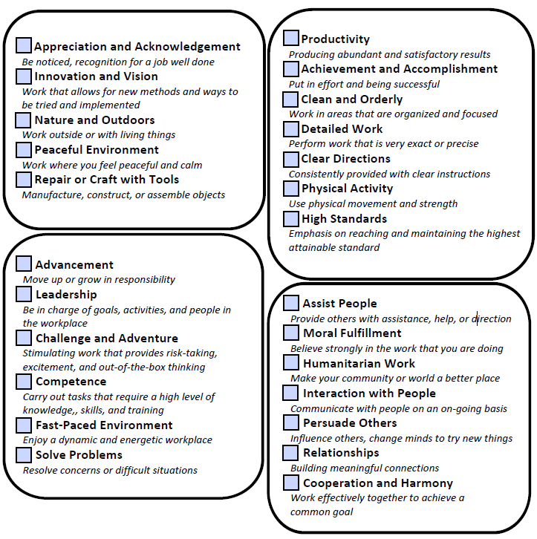

### (Optional) Evidence / Metrics

This one is (mostly) for the advanced / late career folks. Essentially the idea behind evidence or metrics is “the proof is in the pudding”, as they say. It’s one thing to SAY you’re good at something, it’s another thing entirely to be able to prove it.

When we’re choosing a particular piece of evidence or a metric, it should be something that has a hard number attached to it. This is usually a percentage, or a dollar amount, or some sort of quantity, and it’s often attached to a particular project you worked on.

The exact wording is pretty flexible, but it might sound like one of these (continuing from the examples we’ve been using – we’re stretching some of these a bit for effect):

* In my last job, I worked with the doctors to make changes in our discharge process to reduce most patient’s stays by 24 hours.
* I worked with a non-profit client to rework their logo and redesign their website to make it compatible with modern phone browsers, increasing site visits by 25%.
* By collaborating with our construction company, I managed to develop a routine maintenance schedule that reduced emergency repair calls by 30% for my building.
* Using my leadership experience from retail, I got my team organized and working more efficiently by dividing up tasks and we were consistently done 25% faster.
* In my last role, I streamlined our system for new investment accounts, speeding up the process by nearly 30%, reducing errors, and increasing customer satisfaction.
* While I was volunteering, I started writing playful bios for the cats on site, which increased adoption rates by 15% by giving people a better sense of the cat's personality.

You can’t recite seventeen metrics, so whatever you pick should be pretty impressive. And this is not absolutely necessary. Sometimes there is something you did that you can quantify that you are really proud of that is RELEVANT to the kind of job you want to do next. (Cool sounding metrics for a part of the job you hated doing? Not really helpful at this point.)

***THIS IS OPTIONAL!!*** If you’re looking at these examples and either feeling crummy because you don’t have something you can stick a number on, that’s nothing to feel bad about. If you’re reading these examples and thinking “I could make something like that up but it would feel weird / wrong / like I was lying to sound impressive”, that’s okay. (I did say I was stretching a bit here, didn’t I?)

If you read this page and said, nah, I am not feeling that, skip this line and carry on. Really. No harm done. This section won’t even apply to 75% of people who attend the workshop. *Do NOT let the fact that you don’t have metrics keep you from having a brand.*

### Let’s Check In: Remember that context matters!

Alright, we’ve got a goal, maybe some education, stuff we’re good at, personality traits we think define us, and an understanding of what drives us to be us. We even might have a nice crunchy number or timeframe to prove we’ve got what it takes.



Skills

Values

Attributes

Evidence

Job Target, Experience,

Education

NOTE: We’re not going to talk about all of this in our brand! We’re defining the product for now, and when we put it together we’re going to tighten things up to make it easier to memorize and get out without trapping people in the corner.

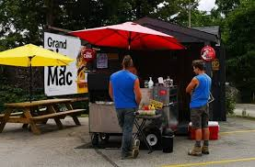At this stage of the game, we have a choice to make depending on where we are, what’s going on, who we are talking to, and how they’ve responded so far. Remember that the personal brand is primarily a **social** response to “what do you do for a living?” It’s certainly not a job interview, and you shouldn’t be treating it as such.



Remember; barbeques, weddings, bar mitzvahs, hot dog lines, broomball, tailgaters, bus stops, and just generally hanging around with people in social settings. Maybe a job fair. It’s an introduction, not a lecture – random strangers probably don’t care about your IPO.



The Personal Brand is sometimes also called an ***elevator pitch*** because the idea is that if you get stuck in an elevator for 5-6 floors with someone and they ask what you do, the answer should fit in that timeframe (about 30 seconds).

## C:\Users\betpun\AppData\Local\Microsoft\Windows\INetCache\Content.MSO\C29B8FC1.tmpSection Three: What do you want? What happens next?

The last part of the brand is throwing the ball back to the other person. You’ve monopolized their time long enough, give them an opening to respond! The reason it depends so much on context is that asking for job leads at a baby shower will probably feel (and come across as) a little tacky or socially inappropriate.

IN **PURELY** SOCIAL SETTINGS: You might want to wrap by asking how the other person knows the hosts or mentioning something about the event you’re at. If they’re looking overwhelmed or bored, this is a good, safe pivot to re-engage them in the discussion. You’ve planted the seed, don’t try to force it to grow at this point if they’re not looking interested.

IN PROFESSIONAL SETTINGS: If you’re at a job fair or a mixer or something, or you’re in an office or other professional setting, it might be better to do a call to action. (For my non-marketing and sales people, that means asking them to help explicitly.) What you ask for at this stage depends on who the person is:

* Do you know anyone who is looking for someone with my background?
  + This does have the virtue of being direct but is very easy to say no to.
* I’m trying to figure out who I could get advice from about getting into industry X.
  + Here we’re not asking directly for a job, we’re trying to network.
* I’m super excited about working for company [X] because [Y].
  + This is more of a job-fair add-on. It shows them you’ve done some homework.
* What do YOU do for a living, anyway [name]?
  + If in doubt, give them a chance to shine! Maybe they’re facing the same problems you are.

## Can you write it **for** me??

Short answer, no.

The tough part about writing out the script is that it is wildly variable depending on all your moving parts and personality. One person might want to start with something like “I’m looking to build on my extensive experience in [industry X] and my education in [field Y]”, while someone who isn’t a natural writer might want something a bit more fill-in-the-blank.

The booklet will provide a number of concrete examples based on the scripts we’ve been using so far to show you how to piece things together. We’ll give you a loose script / framework to start from and you can improve on it over time.

### The importance of Gratitude to set the tone

We encourage people to thank the listener for asking the question. It tends to set the tone for what we’re going to do – we are asking for half a minute or so of their time and it always sounds better to start off grateful than desperate. (Never let them see you sweat. [tm])

Energetically speaking, thanking them before they’ve actually done anything for you does set up a small but subtle imbalance that makes it more likely that they feel like they should help you (so there is something that you should be thanking them for). Remember to start with:

**THANK YOU FOR ASKING!**

### Wording each section

**FIRST LINE:** (Job Title / Experience / Education)

**Variant One:** I have experience and education in my field

* I am looking to build on my [X] years of experience as a [job title] with training in [Z]
  + (or “on my extensive experience as a [job title]”)
* I am looking for work as a [job title]. I have [X] years of experience.
  + Remember, volunteering counts!
  + Education isn’t always necessary if it isn’t directly related.

**Variant Two:** I’m looking to build experience in a new field (e.g new grad, career shift)

* I’m looking to build experience in [industry A] based on my recent [education]”
* I’m looking to build experience in [industry A] based on my [X] number of years of transferrable skills in [industry B].”
  + If you have both, say both!
  + Remember, volunteering counts!

**SECOND LINE:** Skills / Attributes / Values // **Evidence (Metrics)

Remember I said, we aren’t going to include everything here? We narrowed it down to three things because we’re going to pick one of each. Again, we have to keep this as short as possible so we’re not boring the other person. I might allow you two of any one of the S / A / V items – what we are NOT going to do is rattle off nine things!!

* I am great at [primary skill] because I am [attribute] and I value [value].

That’s it. That’s all. It’s NOT A JOB INTERVIEW!!. Do NOT overwhelm the other person. I cannot stress this enough. This is not about you cramming as much data as you can down the other person’s throat while you have them trapped at the punch bowl.

NOTE: If you are at a job fair, meet and greet, or other professional setting, you can use up to two items for each section for a maximum of six for your verbal introduction. These are settings where more professional detail is expected, but it still has to be easy to remember.

* I am great at [skills a and b] because I am [attribute a and b] and I value [value a and b].

*\*\*OPTIONAL* If you have metrics, you can include one BRIEF line here about that – not both:

* *I’m especially proud of [thing I did and what the outcome was].*

**THIRD LINE**: Call to Action

This is going to vary depending on your situation, environment, and goals. Read over the Call to Action section again if you’re not sure. However, in a pinch, you can fall back on this:

* Do you know anyone who is looking for someone with my background? [or]
* What do YOU do for a living, [name]?”

### Personal Brand Scripts (samples)

*Let’s see if you can “hear” all the parts of a brand in these mini-scripts!*

**BUS STOP SMALL TALK:**

Thank you for asking! I’m looking for work as a nurse specializing in geriatric care with seven years of experience in Winnipeg hospitals. I have my Registered Nursing Diploma from the University of Manitoba. I'm great at triage because I am compassionate and value competency. In my last job, I worked with the doctors to make changes in our discharge process to reduce most patient’s stays by 24 hours. What do you do for a living?

**SELF-TAUGHT JOB CHANGE:**

Thank you for asking! I’m looking to build experience as a web designer specializing in graphic design. During the pandemic, I’ve been studying front end development through CodeAcademy and LinkedIn Learning. I'm especially proud of my skills in accessible design because I am detail oriented and value building relationships. I worked with a non-profit client to rework their logo and redesign their website to make it compatible with modern phone browsers, increasing site visits by 25%. Do you know anyone who is looking to hire a web designer?

**BOMBER TAILGATE PARTY:**

Thank you for asking! I’m looking for work as a custodian with extensive experience working in residential buildings and property management. I’m working on my Power Engineer Class 5 and I have two levels of Carpentry from Red River College. I'm good at fixing things and problem solving because I am results oriented and value achievement. I feel like I just need an introduction to get things going - do you know anyone in the field?

**CHANGING JOBS:**

Thank you for asking! I’m looking to build experience in the construction industry because I like working with my hands to make cool things. I volunteered for Habitat for Humanity before the pandemic and I want to make building things into my career. Using my leadership experience from retail, I got my team organized and working more efficiently by dividing up tasks and we were consistently done 25% faster. I discovered I'm good at carpentry because I am analytical and value doing precise work. I'm trying to figure out who I could get advice from about getting into the industry. Do you know anybody who could help?

**JOB FAIR:**

Thank you for asking! I’m looking for work as an accounting clerk with twelve years of international experience in the banking and financial industry. Before I came to Canada, I got a Bachelor of Economics with a minor in Accounting from Ashoka University in New Delhi, India. I am good at forecasting because I am accurate and value high standards. In my last role, I streamlined our system for new investment accounts, speeding up the process by nearly 30%, reducing errors, and increasing customer satisfaction. I'm super excited about working for RBC because I'm already a client and the staff are great. What roles do you have open?

**WEDDING RECEPTION:**

Thank you for asking! I’m looking for a job where I can work with animals and help them find permanent and loving homes. Recently I’ve been volunteering for Annie’s Attic and really enjoy working with cats. I started writing playful bios for the cats on site, which increased adoption rates by 15% by giving people a better sense of the cat's personality. How do you know the bride and groom?



# Putting it all together

Let’s gather all of our data in one place:

Job Title / Industry

Years of Experience

Relevant Education

Skills



Attributes



Values



Evidence / Metrics (if applicable)



Call to Action

# Write It Out – Draft your Personal Brand here!

**THANK YOU FOR ASKING!**

**First Line:** Job Title / Industry -- # of years experience – education

**Second Line**: Skill – Attribute – Value (up to two of each)

**(OPTIONAL):** Evidence / Accomplishment / Metric Statement

**Last Line:** Call to Action / Invitation to Keep Talking

(Refer back to Page 26 to grab your specific content)

# Practice makes progression and then permanence!

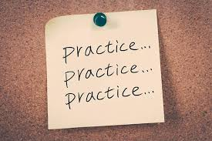Now that we’ve had a change to write out our brand and test it a few times, it’s important to remember that you need to PRACTICE it.

It’s not going to feel comfortable at first. You need to say it over and over until you have internalized it, sort of like a monologue in a play or a movie. You never know when you’ll have an opportunity to spin it out, or with whom, so you have to Be Prepared.

It can feel really **weird** to “toot our own horn”, or to speak positively about ourselves, especially if we come from a culture that is more community based than focused on individual success.



When you are first learning your brand, it can be helpful to write it out (or even just the high points) on some index cards and stick them up around your house. Introduce yourself to the dishes, the laundry, and the bathroom mirror until it feels natural.

Practice doesn’t make perfect. Your brand will NEVER be perfect, it has to grow and change WITH you as your career goals grow and change. What it will do is make it permanent, so you won’t have to think about it so hard.



# Where else can we use our branding statement?

**LinkedIn Summary:**

****Congratulations! Do you have a LinkedIn Account? You now have a nice, friendly About section that talks about your goals and aspirations. In fact, you could probably add more items in, since we’re not as worried about boring people.

**[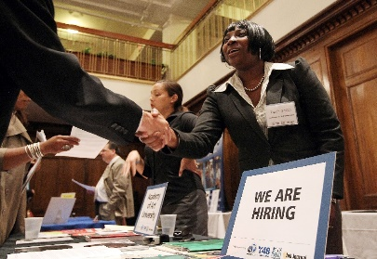](http://www.google.ca/url?sa=i&rct=j&q=&esrc=s&source=images&cd=&cad=rja&uact=8&ved=2ahUKEwjhya222rXdAhVH-lQKHa7zAnUQjRx6BAgBEAU&url=http://fortune.com/2015/01/08/usa-layoffs-in-2014/&psig=AOvVaw2GNPxYIORmp8k6XfRHKJa1&ust=1536849807751827)Job Fair / Career Fair Introductions:**

Do you go to career fairs and throw your resume at people and run away? Don’t be THAT person! The company rep on the other side will appreciate your polished, professional introduction and you will be more memorable as a result. In a good way.

**Networking Events:**

If you have an opportunity to attend a mixer or networking event (something like the Chamber of Commerce meet and greets) at least you’ll be able to introduce yourself professionally and not feel like the only kid in class who didn’t study for the test.

**Family, Friends, and Social Events:**

Come on, let’s face it, they probably don’t really know your career aspirations as well as you think. ***Complaining*** about your job search doesn’t count. Start by reaching out to the people in your network bubble and seeing what they think of your brand. Test it out at the pickleball tournament you didn’t want to go to, or while you wait for the bus.

## In Summary

1. You have a much better idea of the product you’re selling – that’s you!
2. You have a Personal Brand. (Or at least the Sourdough Starter Edition [tm].)
3. You have a sense of when, where, and how to use it.

Now go forth with your newfound confidence and use your personal brand to **help others help you be successful** in tapping into the hidden job market!

**NOTES**

**NEW PEOPLE IN YOUR NETWORK (from class)**

*(if you are attending our in person workshop, use this page to capture contact information for people you want to stay in touch with afterwards!)*

Name:

Phone Number:

Email Address:

Name:

Phone Number:

Email Address:

Name:

Phone Number:

Email Address:

Name:

Phone Number:

Email Address:

Name:

Phone Number:

Email Address:

Name:

Phone Number:

Email Address:

## Map out your network here

