2023 – 2024
ANNUAL REPORT

Osborne Village Resource Centre Manitoba Inc.

  - Osborne Street
Winnipeg, MB R3L 1Y4
http://www.ovrc.ca

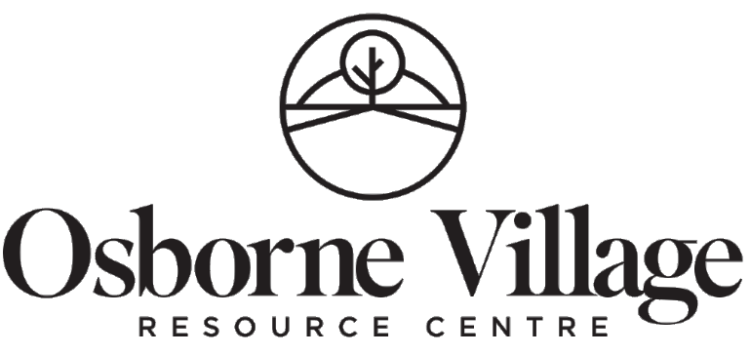

October 16, 2024

Table of Contents
Table of Contents 2
OVRC Mission Statement 3
We Believe 3
Our Team 3
Core Services 4
Resumes / Cover Letters 5
Career Counselling 5
Value Added Services 6
2023 – 2024 Workshop Offerings 6
2023 – 2024 Workshop Offerings (cont.) 7
Workshop Feedback 2023 - 2024 8
Overview of Social Media Channels’ Performance 9
2023 – 2024 Message from the Executive Director 10
2023 – 2024 Message from the Chair, Board of Directors 11
2023 – 2024 Board of Directors 12
2023 – 2024 Financials 12
Success by Numbers 13
Highlight of Services 2023 - 2024 13
2023 – 2024 Client Feedback 14
2023 – 2024 Client Feedback (cont.) 17
2023 – 2024 Client Feedback (cont.) 18

OVRC Mission Statement

The Osborne Village Resource Centre is committed to empowering individuals to advance their careers (take their next career step) and embrace an ever-changing job market with confidence and resilience. Our goal is to facilitate employment and career development, equipping our community with the tools and knowledge needed to thrive in today's dynamic job landscape.

We empower individuals to navigate the ever-changing job market with confidence and resilience. Serving as a vital link to Winnipeg's labor market, we actively promote access to essential community resources, immigrant services, professional networks, and educational opportunities, including post-secondary and apprenticeship programs.

At our heart, we are a warm, inclusive haven, dedicated to nurturing personal growth and fostering purposeful goal setting. Together, we strive to create a supportive environment where individuals can unlock their fullest potential and achieve their aspirations.

We Believe

- Empowering our clients to navigate the present and future labour market through continual self-assessment and strategic career development planning.

- Our clients experience empowerment when they take charge of their job search journey.

- Our clients increase their confidence after gaining a clear understanding of who they are and their value within the workplace and identifying work meaningful for them.

- When clients can identify their unique skills and attributes, they become empowered and take charge of their job search journey.

- Clients maximize their opportunities of securing meaningful employment by using a variety of job search activities and targeted job search strategies.

- Matching the client's skills, abilities, values, and personality to their job search and career path planning increases the opportunity to find the perfect fit. Resulting in long-term employment and improved quality of life.

Our Team
Executive Director: Keith Robinson
Employment Facilitators: Brian Yasui
Betty Punkert
Lisa Elmhurst
Career Counselors: Laurie Sutherland
Ahniko Handford
Administrative Professional: Judy Recksiedler
Social Media: Olena Yurchenko
Overview of Services

At OVRC, we offer a variety of services designed to support job seekers at different stages of their career journey. Our services include:

Resume Building: Developing targeted resumes that highlight your strengths.
Cover Letter Development: Creating personalized cover letters that stand out to employers.
Career Counselling: Providing expert support and advice to guide you in your career decisions.
Pre-Employment Workshops: Equipping you with essential skills for job readiness.
Self-Directed Job Search: Access to eleven computers for independent job searching.
We understand that every client has unique needs. That is why we allow you to select the specific services that align with your goals, empowering you to take control of your job search and develop lifelong skills.

Our goal is to create a supportive and interactive environment. Whether during one-on-one appointments, workshops, or while using our self-directed search resources, we aim to facilitate open discussions and resolve challenges. This approach helps open doors to new possibilities and ensures a meaningful and positive experience.

Core Services
OVRC stands out for its unique approach to career support, allowing clients the freedom to choose services based on individual needs.

Whether clients are employed, underemployed, or unemployed, our services are accessible to everyone. We are dedicated to providing resources that help each client build the skills and self-confidence necessary for career success.

Our flexible model allows clients to select the specific support they need, enhancing their ability to improve their work situation. This flexibility extends to timing and service delivery, accommodating each individual's schedule and preferences.
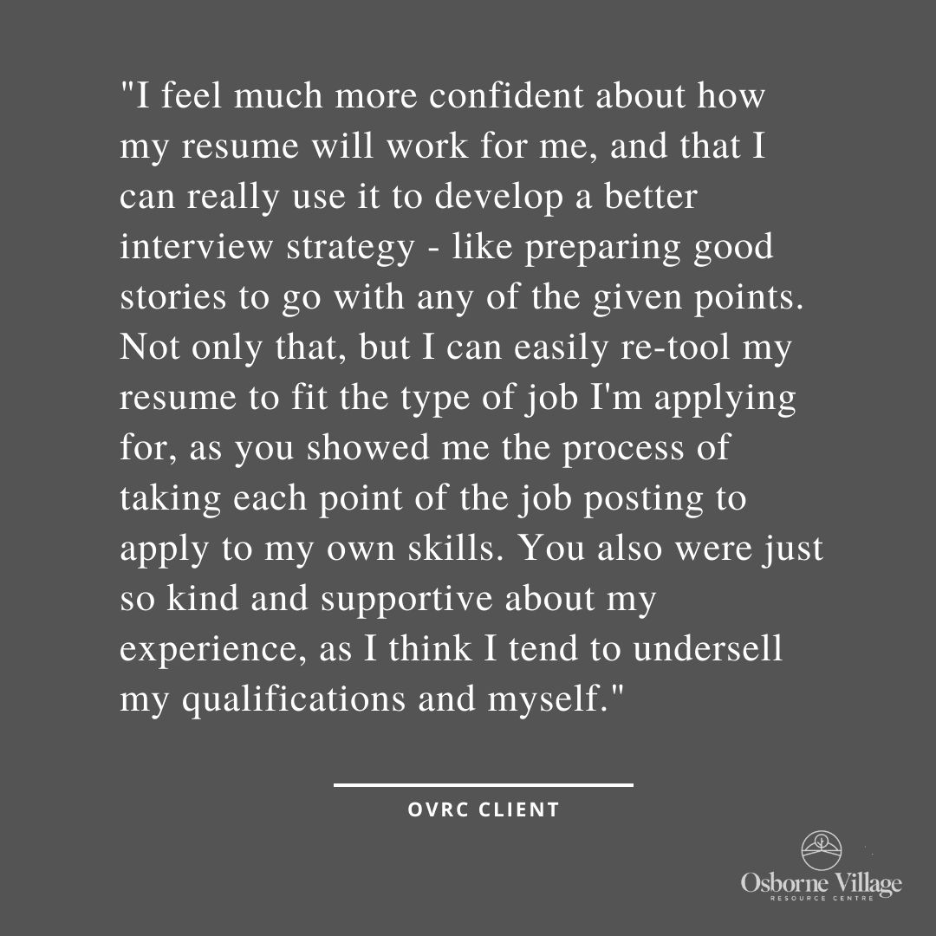
In addition to assisting the unemployed and underemployed, OVRC is among the few agencies that also support mis-employed clients. This proactive approach helps mitigate the risk of needing financial assistance if they face challenges in their current employment.

By offering this broad range of services and support, OVRC ensures that, all clients—regardless of their employment status—can access valuable resources to advance their careers and achieve their professional goals.

Resumes / Cover Letters

We help clients get excited about creating responsive, skills-focused resumes that capture the first-rate experience and attributes they bring to their roles, using language we know the employer will hear. Our clients also discover how “branding” their uniqueness - composed of those shiny, sparkly competencies that make them an outstanding candidate – makes them memorable and captures the employer’s attention.

Our clients learn how to write call-to-action cover letters that introduce themselves to the employer using the employers’ words and their own to describe the dedication, commitment, and accomplishments that capture an employer’s imagination. Why do targeted cover letters improve resumes’ efficiency from 30 -50 %? Because humans hire humans who show their enthusiasm!

- Clients that worked with employment facilitators in resume / cover letter development have secured meaningful employment at an average of 422 clients per year.
- In the contact year of 2023 – 2024 OVRC 458 clients secured employment.

Career Counselling

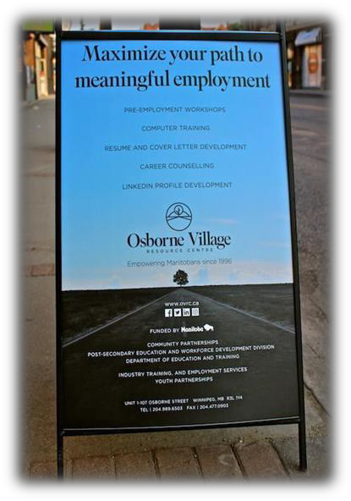
Unleash your full potential by partnering with a career counsellor to reflect on your unique values, skills, experience, and personality type. Dive deep into the various sectors of the Manitoba labour market, gaining the insights and tools you need to research the best-fit-for-you career paths. Armed with this information, you will be ready to choose occupations that align with your goals and aspirations.

- Together, we will craft a personalized SMART action plan—specific, measurable, attainable, realistic, and timely—to guide you toward your next career. If you:
- realize you already have the skills to transition into a new field; or
- would like to stay in your current role but explore new duties that align better with your strengths; or
- are seeking a fresh start in a different sector or company; or
- have an interest in retraining with potential funding assistance

We can’t wait to help you get there! Ready to discover your career "best fit"?

Value Added Services

2023 – 2024 Workshop Offerings


"What do you do for a living?" is a question that can be difficult to answer and create some anxiety. If you are new to the market or changing careers, it can be hard to talk about your professional goals. ("Anything" is not a goal.) Having a short, direct Personal Brand (elevator pitch) can help people in your network understand what you are looking for so they can help you more effectively.


Do you know the type of work you are looking for but you’re just not sure how to find the right company? Want to find a company that you actually want to work for? People who find companies that are a good “fit” for them, generally find greater satisfaction in their work. (under redevelopment)


"Everyone says" you're more likely to get a job from someone you know than from applying online. But what if you don't know anyone, or at least the right people? Learn how to set up a Career Conversation - a discussion where you ask someone you respect in your industry for career advice in order to build a relationship, expand your network, and learn what you need to know to be successful.

2023 – 2024 Workshop Offerings (cont.)


Elevate your job search with a standout headline that showcases your strengths! We'll help you craft a compelling “About” section while brainstorming potential employers who align with your values and passions. Learn to master strategic job search methods. Then investigate the career paths of professionals in your field by connecting with key industry associations, and discover how engaging with members of your community can open doors and boost your career journey! (one on one)


Develop confidence in the basics you need to succeed in job interviews. Learn how to respond to both standard and behavioral interview questions, and better understand the interview process and its unwritten rules. This workshop will give you confidence in reading a job ad like an employer ("but what will they ASK?"), creating your own responses, and opportunities for practice and feedback (under development)

Working together…. For your success…


Workshop Feedback 2023 - 2024

“I just wanted to express my gratitude for your assistance, which I found to be of such great use for me at this time in my life. You guided me to clarify my own values, strengths and uniqueness.”
CAREER EXPLORATION
“I gained confidence in how I present myself and having a key phrase. Even if I am not working!”
BRANDING YOURSELF
“I just want to say thank you for all your help. You really boosted my confidence, and helped me to learn to 'sell' myself.
I had an interview and I got the job and I start tomorrow! I am so excited; it is such a good fit for me.”
Interview Skills
“My experience with the informational interviews was a little tough at first. With most things, practice made it easier, and I got some helpful direction and information for my goals. It made the whole process a lot easier.”
Career Conversations
“As a newcomer, it is imperative to find a job quickly. However, if I plan, I could find my dream job. My research will be more targeted thanks to the different tools from the workshop.”
MY IDEAL COMPANY LIST

Overview of Social Media Channels’ Performance

Facebook:
In the last 90 days, OVRC reached more than 350 people organically, with no paid ads.
Total Followers: 620
New Followers: 12 (since July 5th)
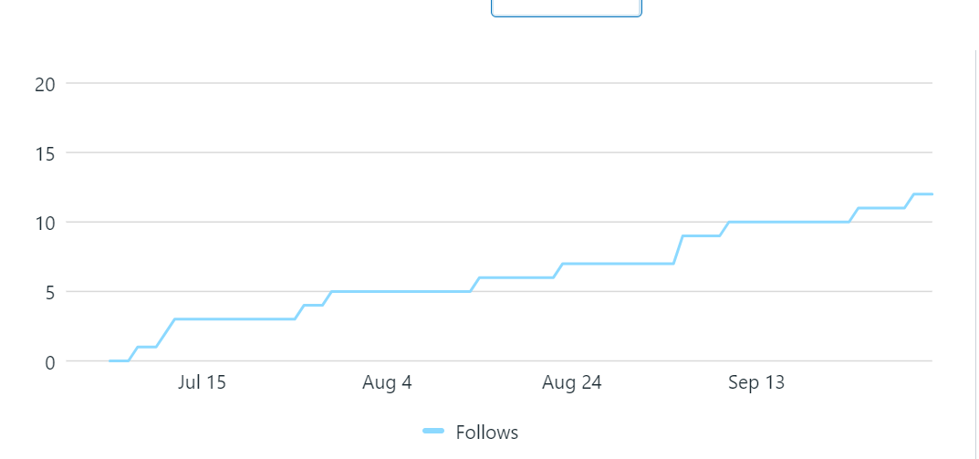
Instagram:

Total Followers: 713
New Followers: 23 (since July 5th)
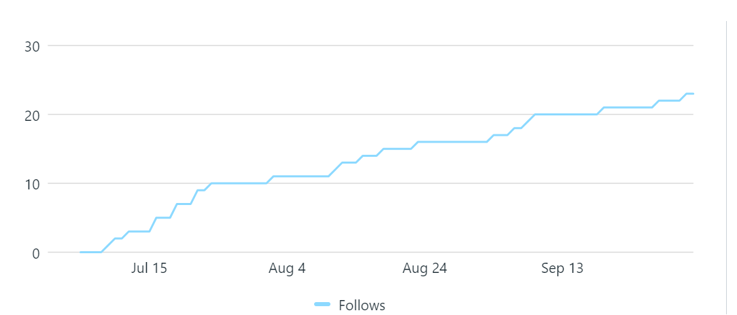

For both Facebook and Instagram, our audience is 63.5% women and 36.5% men. The largest age group is 35-44 years old. Most of our audience is from the Winnipeg area.
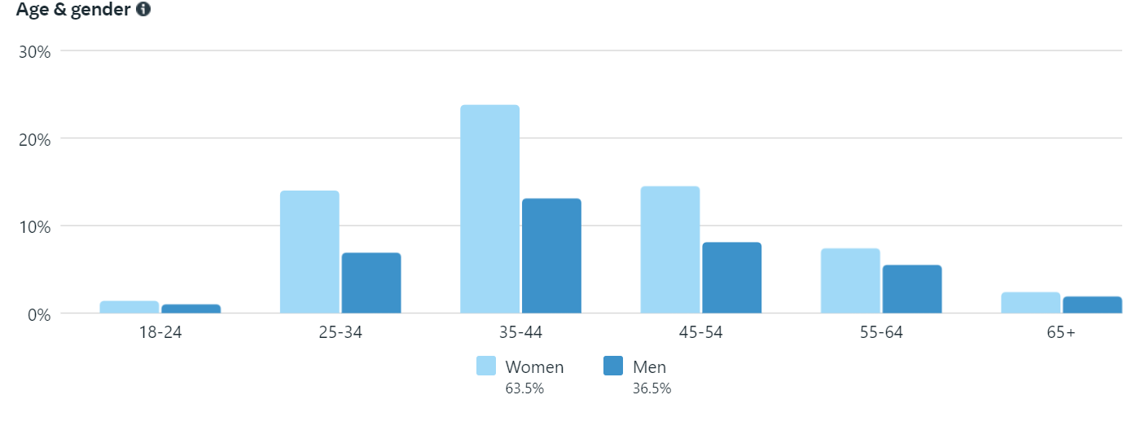
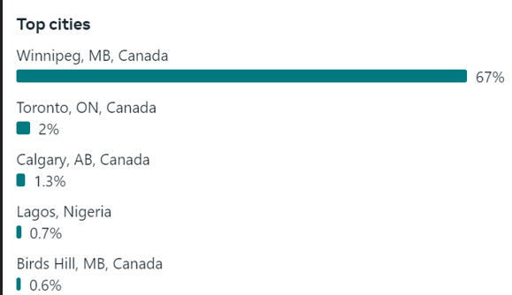

Our audience enjoys informative content, whether it's workshop information or engaging content with attractive images.

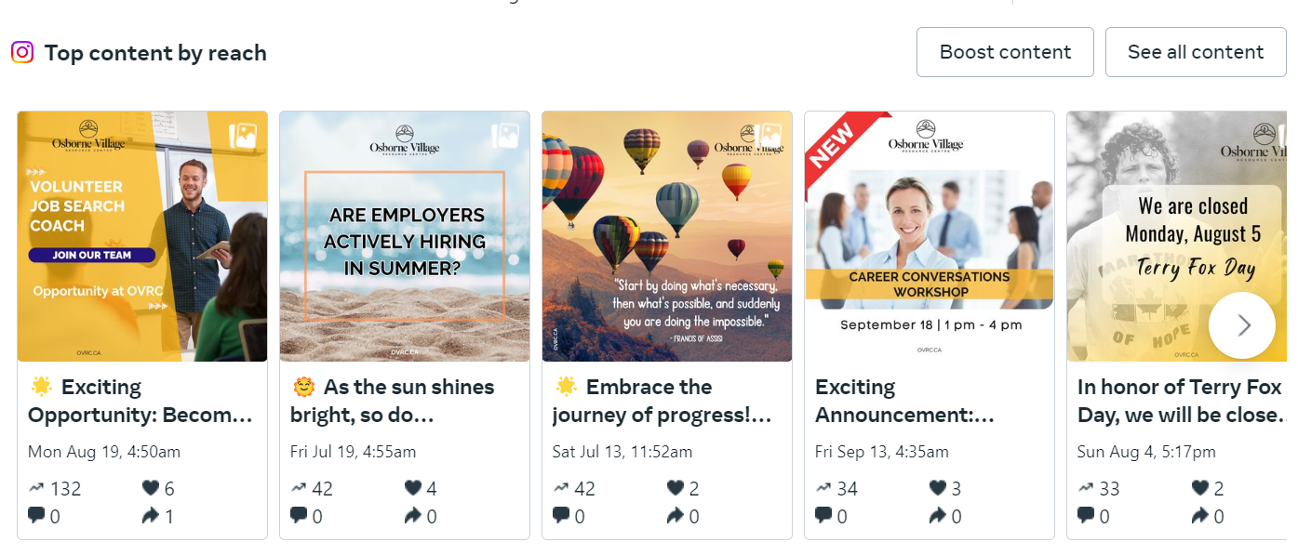

Recent Facebook and Instagram Changes:
The organic reach of Facebook posts might decline, even if the quantity and content of the posts remain consistent.
Algorithm Changes: Facebook prioritizes content from friends and family over business pages.

LinkedIn:
OVRC has 2,105 followers, which is a 5% increase from 2023.
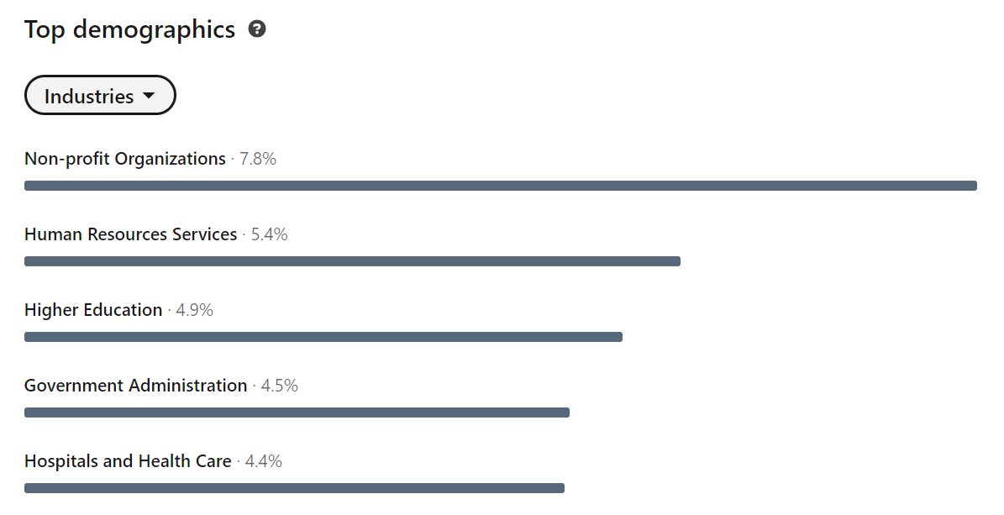
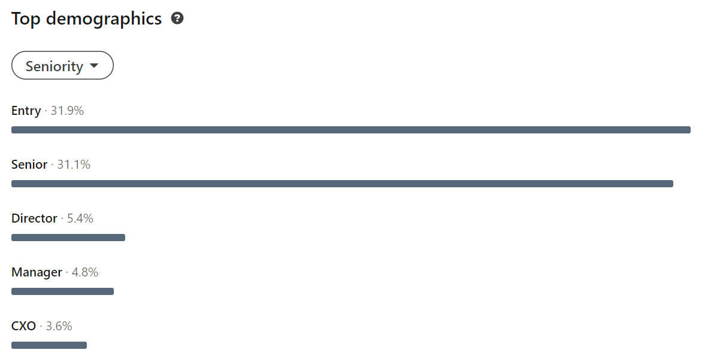
Where our audience is from? ….and who are they?:

A similar number of people with entry-level and senior positions read our LinkedIn posts.
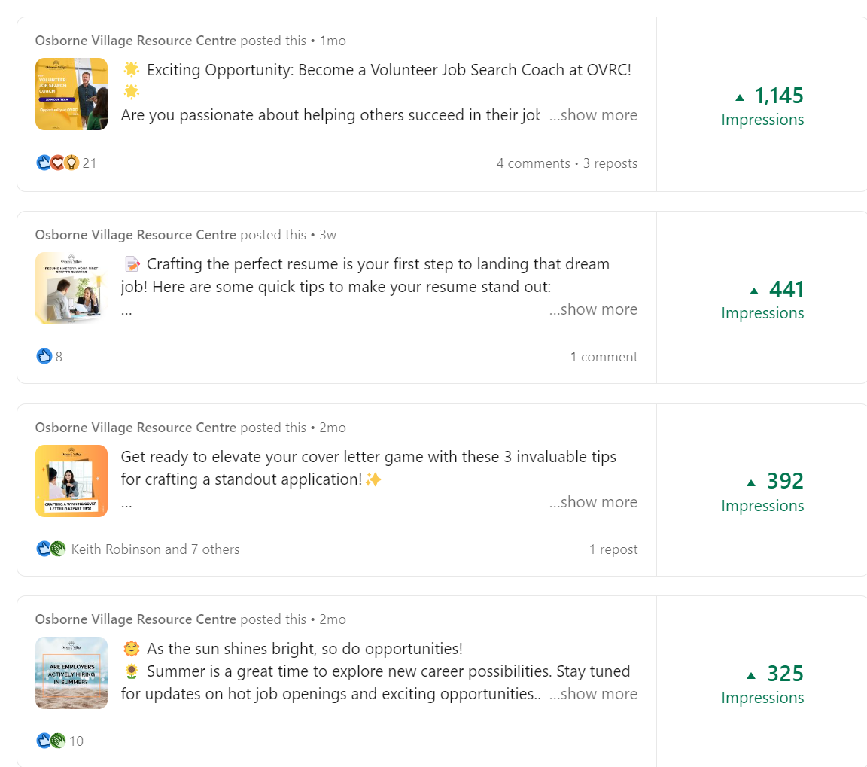
Our audience enjoys posts about volunteer opportunities, tips on creating effective resumes and cover letters, and seasonal posts with attractive mages.

Let's keep our social media visitors engaged with valuable content while providing them with updates on our services. We want to show that we are open to people and ready to help them find their dream job.

2023 – 2024 Message from the Executive Director
The strength of OVRC truly lies in the relationships built between staff and clients. Right from the first call sets a warm and welcoming tone, ensuring that each client feels heard and his or her specific needs are understood. Professionalism and experience are vital in connecting clients to the right services, paving the way for positive outcomes. This caring culture makes OVRC stand out and truly impacts lives. The personal touch makes all the difference!

OVRC team is dedicated to enhancing clients' confidence and skills for meaningful employment, 458 out of 735 unemployed individuals selected for the project have found employment through Self-directed or Directed services at the Centre. Additionally, 108 clients were referred to another Service Agency, and 74 returned to Further Education. The total outcomes for OVRC are 663, which represents 87% of the funded 735 clients. OVRC registered 870 clients surpassing our funding goal of 735 by 135 clients, increasing the return on investment to our provincial funder.

OVRC has seen growth in its workshops and career counseling services. There is a five-week wait time for one-on-one employment appointments and an eight-week wait for one-on-one career counseling appointments, indicating a high demand for these services.

I successfully received a $25,000 grant from The Winnipeg Foundation to replace our carpets and paint our office space. We have never had our space painted in the 20 years that I have been at OVRC. The carpeting is 12 years ago and was of low quality. OVRC can provide service in our space for years. I am so thankful to The Winnipeg Foundation for their continued support over the years.

Additionally I received a grant from Assiniboine Credit Union for $5,000 for Staff Development. Staff have benefited from learning new skills and techniques to assist clients in overcoming anxiety from losing employment. Thank you for your ongoing support of our team at OVRC. Focusing on skill development is essential for us to deliver high-quality service to our clients, and this grant made a significant impact. We truly appreciate it!

I would like to express my gratitude to the OVRC Board of Directors for their dedicated efforts over the past year. Your talents and contributions have significantly strengthened OVRC and prepared it for a bright future. The completion of numerous governance tasks and the progress in updating important documents are vital steps toward ensuring the organization has continued success. Thank you for your hard work and commitment!

Sincerely,
Keith Robinson - Executive Director

2023 – 2024 Message from the Chair, Board of Directors

It is with immense pride that we reflect on the strength and resilience of OVRC in its mission to support our community members on their path to meaningful employment. This past year has been a testament to our unwavering commitment to service, and we have witnessed firsthand the dedication and passion that drives our team forward.

However, this success is not the achievement of any one individual. It is the collective effort of a devoted team, working hand in hand to help our clients achieve their employment goals. From frontline staff to leadership, each person plays a crucial role in making our vision a reality.

While we have faced our fair share of challenges in recent years, we can say with absolute confidence that the OVRC team has remained steadfast in its mission to serve those who have reached out to us for help and entrusted their employment future in our hands.

Looking ahead, we are certain that with the dedication of our exceptional team and the continued support from our partners, we will rise to meet any new challenges that may come our way. Together, we will ensure that our clients receive the guidance and resources they need to succeed in their professional journeys.

Finally, we want to extend our heartfelt thanks to our clients for placing their trust in our dedicated staff that we love so much, our Executive Director and to the Board of Directors at OVRC for their hard work, perseverance, and spirit over the past year. It is through your collective efforts that we can make such a meaningful difference in the lives of those we serve.

Sincerely,

John Helliar and Gregory Geva
Chairs, Board of Directors

2023 – 2024 Board of Directors

Co Chairperson Leah Buermeyer
Co Chairperson Gregory Geva - Finance Committee
Treasurer Garry Reid - Finance Committee
Co Treasurer Lisbeth Aragones – Finance Committee
Secretary Melissa McCann - Governance Committee
Members John Helliar - Governance Committee
Dangy Ramos Suazo - Governance Committee
Adriano Magnifico - Governance Committee
Raghu Rajendran - HR Committee
Larysa Motruk - HR Committee

Expenses
Staff 72%

Rent 20%

Supplies 5%

Other 3%
2023 – 2024 Financials

Total Staff Costs includes: Staff Salaries, CPP, EI & Income Tax, and Worker’s Compensation Board
Rent Costs includes: Rent, Hydro, Telephone, Internet, Cleaning, and Alarm.
Other Costs includes: Building / Liability Insurance, Board Insurance, Banking / Interest, Accounting, Payroll Administration, Computer Service & Repair, Staff Development and Building Maintenance
Budget Notes: OVRC approved budget was $425, 906.

Success by Numbers
Each year, our team of three Employment Facilitators and two Career Counsellors help clients by providing in-depth one-on-one and group workshop training:

Highlight of Services 2023 - 2024
3055 | Services to the community (includes all appointments, workshops and self-directed clients engaged in independent job search
1170 | One-on-One Resume and/or Cover Letter Appointments were provided by three Employment Facilitators.
865 | Career Counselling Appointments were provided by two Career Counsellors.
483 | Clients participated in OVRC’s Pre--Employment Services/Workshops.
305 | Interview Skills Appointments ( Both one on one and in Workshops)
232 | Other Services (Informational Interviews/LinkedIn/Online Applications)
458 | Clients secured meaningful employment in 2023-2024.

2023 – 2024 Client Feedback

I wanted to thank you so much for all your help. I am not ashamed to say I came in, as a broken man with what I thought were bleak prospects. Now I am looking at getting a trial run at a place I want to work at! It truly feels amazing. Thank you for your support, knowledge, and kindness. I am in a different place today because of you! Thanks so much.

Thank you and I did celebrate! You should honestly get the credit though because my boss said my resume was exceptional!

I heard of you people through a friend first and then I went to your website and found a number I called it and within a week I had an apt and a day to make my resume. I came in, just said what I did in the past and you turned it into gold! I was there probably an hour and I was so happy when I left and was excited to start using my new resume.

They started me on part time and within the month, I got a full time position with a great wage. I started as an admin assistant and then got promoted to intake coordinator. I seriously never thought I would be making 28$ an hour. It is the most I have ever made, the happiest I’ve ever been, and it’s all thanks to you!

You should really give yourself a pat on the back for helping me and probably helping a lot more people like me! Keep up the good work.

I just wanted to take a minute to let you both know I have received the job I was pursuing and couldn't be happier. I know this will be a great fit with my values and budget, as well as a great place to grow and develop my career. Shift work isn't very glamorous but being childless this actually has a lot of benefits to my schedule such as longer "weekends". I thank you both so much for your help and direction. I am very doubtful I would have gotten this interview without your guidance.

I have great news to share I just received and accepted the conditional offer for this position today, a few minutes ago.

I am grateful for all the support and encouragement from you and OVRC! Without this support, I would not be able to stand out from other peer candidates on the cover letter and resume, and do well in preparing for the interviews.

Just wanted to share the great news: I prepared my soft pitch and added a graphic piece with a slogan and a promotional campaign as part of my presentation. Not only I did great, they called me letting me know that it was so difficult for them to come up with the decision that the ended up hiring both last candidates. They gave the Fund Development Coordinator position to the other candidate, and wrote a new job description for me: I will be the Marketing Development Officer for the Agency.
I am so thrilled it worked this way, I feel like I landed my dream job.

So thanks for your help and encouragement in the very short time we were able to meet. Your guidance was essential in my job search and made me understand what my strengths were and what is that I really wanted to do.

Hope to see you soon. I am very appreciative of the Agency and I value the job you guys all do to help individuals like me on a daily basis. Have a great rest of the summer. Best regards and thanks again.

I always wanted to share my feedback on the service I received at OVRC. I am so impressed and inspired by the high standards of service and dedication of the staff at OVRC. I was disappointed by the support I received from other centers and somebody mentioned OVRC. I thanked that person later for pointing me in the right direction. I did attend a workshop on 'branding yourself' and there were others that I could not make it to. That was extremely helpful and motivating. Now I come to the service Lisa provided. She helped me write three job-specific resumes and cover letters. I must say the sessions with her used to be time-consuming but it was always worth it. The final product at the end of the session was always professional and impressive. Lisa does her job exceptionally well. I would like to relate a scenario here. I applied at RRC for ESL/EAL positions in past at least three times and was never shortlisted for an interview. I decided to quit on that. The last time they advertised for a position I spoke with Lisa and followed her directions in writing my cover letter and resume. I received an invitation for an interview which I may not take because I would have started another job already. The other resumes that she helped me with are also equally effective. Anytime I sent an application with the cover letter and resume set by Lisa four out of five times I receive an interview invitation. I would like to thank you and Lisa for providing such support desperately needed by people like me. Thanks and stay blessed.

I want to share that I had a very positive experience with the OVRC. I hope these words below express it.

From meeting with a professional who helped me to think about my career path and how to view and communicate who I was to another professional who met with me with much patience to do a similar process but applied to my resume and then worked to express that adequately in not one, but two different resume profiles, to the staff of the OVRC, that was welcoming and professional on the occasions I visited in person or had the first contact, or wanted to make an appointment.

But beyond the professionalism and quality of the services, I want to emphasize the human quality of everyone from the OVRC I had the chance to interact with. There was always respect, warmth, and positiveness without creating false expectations that made the experience not very good but excellent

We tend to think of ourselves for what we do. And when we are in a stage of change of career path, we have a blurry image of ourselves. The skill, art, and humane qualities of the OVRC professionals allow them to see through the blur and give us back a clear reflection of who we are and who we can become.

No matter what happens or how technology changes and best practices improve, please keep the exceptional humane quality. That is your staff. We can forget (or forgive) what someone tells us, even what someone does to us. But we always remember how someone made us feel. And I have the best memories of how I felt when dealing with the OVRC professionals. And I got the job I wanted! Big hug and thank you,

I just want to thank you for being patient with me. I have been off work for several years, due to the tragedy I shared with you. I honestly did not think that I would even be able to recall what I did and learned at university because it has been so long. You took the time to ask me questions, and listen. You allowed me to help recall information by allowing me to tell you of my professional experiences as a story. This helped me to remember much more than I thought possible. I did not have any confidence before I stepped through your door. Now I do. I appreciate the time you took to help me think of how I can re-enter the workforce. I have hope for the future.

When I first came to see you, I was juggling multiple jobs, without the certainty that any of them were what I really wanted to be doing, or that they would lead me there. I was struggling with impostor syndrome, not knowing how much energy to commit to which career avenues, and wondering whether I should just abandon everything and start over from scratch. Now, I have less insecurity and a better sense of belonging in my current career/professional development opportunities. I also have a clearer image of what I value in a workplace/career, and I know which paths to continue down to create those environments for myself so I can be my best self and help others most effectively. The most valuable parts of working with Laurie were: getting a clearer sense of my values and strengths, and how I can channel those into the careers I'm currently pursuing -- getting more insight into my personality and how I can harness my natural strengths to help others -- and having a frank conversation about impostor syndrome, finding the root of it, and dismantling the core beliefs/assumptions that were feeding it, so I can now pursue a career in translation without the thought "you don't belong here" looming over my head.

2023 – 2024 Client Feedback (cont.)

Thanks again for helping me with my cover letter and resume. You did a fantastic job and went over and beyond my expectations. I really appreciate the time and effort you put into helping me. You are truly skilled at what you do and I’m so happy that I had the opportunity to meet with you.

My experience at Osborne Village Resource Centre was wonderful and the atmosphere was really welcoming. I will definitely be referring and recommending all my friends to your organization. Lisa, you are great at what you do and I can’t express enough how thankful I am. It truly meant a lot to me and I am now confident that I can move forward with my job search.

I wanted to thank everyone at OVRC for supporting and encouraging me along my journey. I took advantage of all the workshops and resources and met with each one of you individually (combined it was many times). I am grateful that OVRC was there for me when I needed it most. Your compassion, coaching, and empowerment is appreciated.

Thank you so much for your great work today. Before I called the resource center, I was told by my professor there was someone who could help the newcomers write their resumes. Right now, after a wonderful experience this afternoon, I can say I received a priceless gift from you, the community and the government. In my country, there is a famous idiom: better teach a man how to fish than give him fish. You have already given me the best lesson for resume writing which I have never thought I could get. You are a great teacher, I will be grateful for that in my life. I wish I could tell you good news about my job search soon.

2023 – 2024 Client Feedback (cont.)



